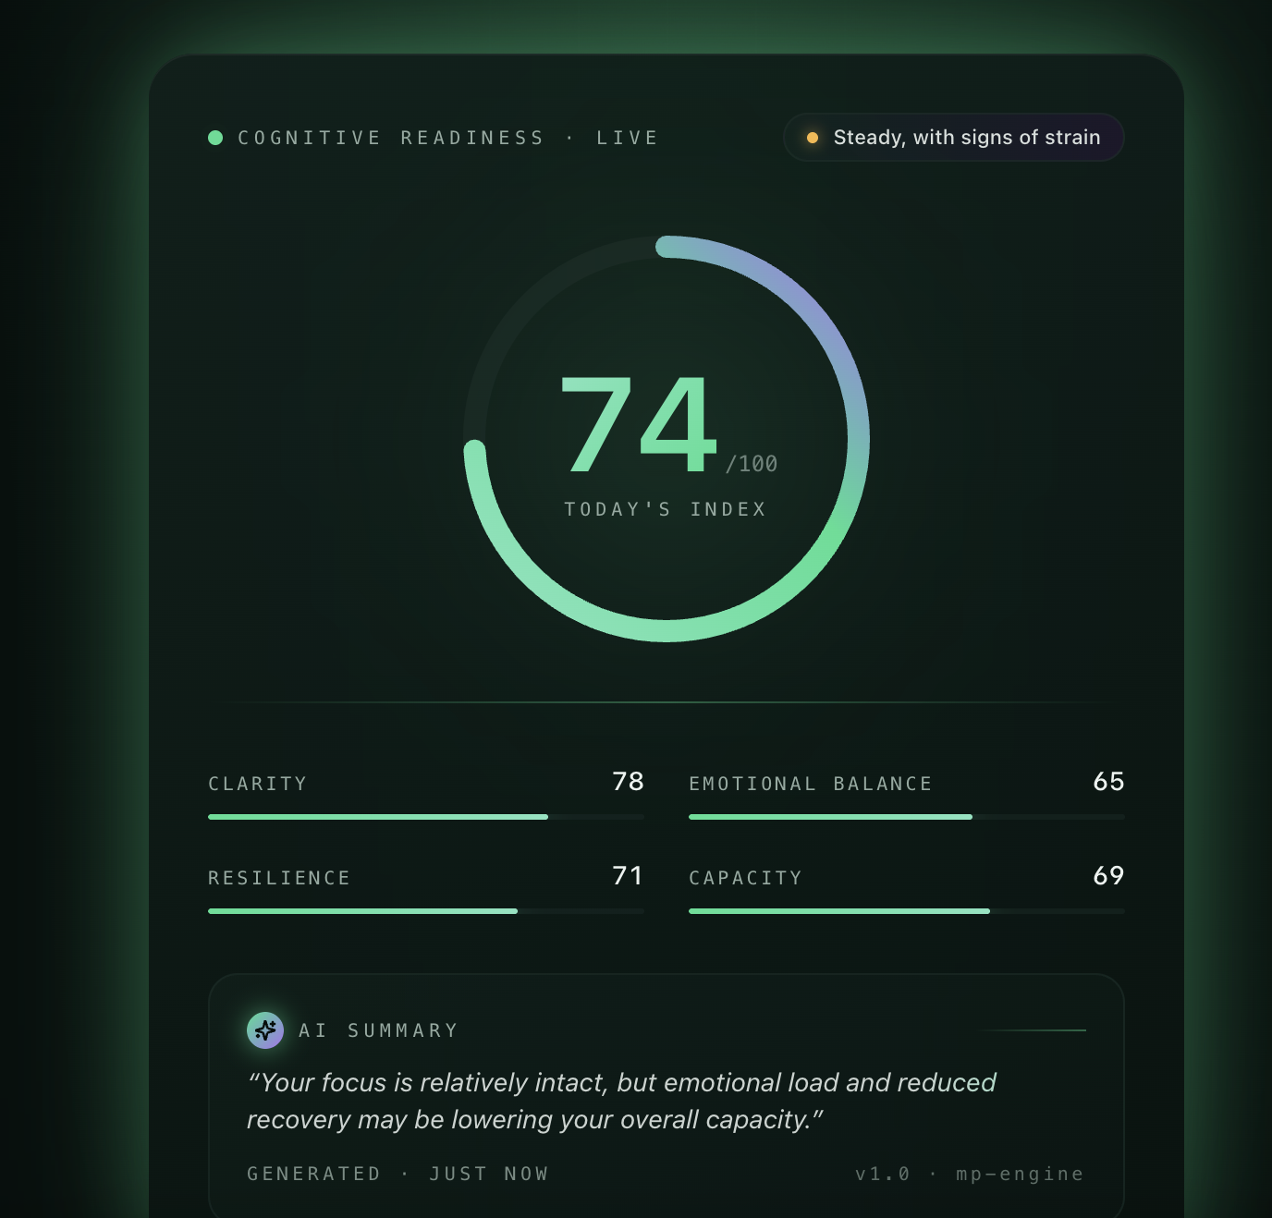
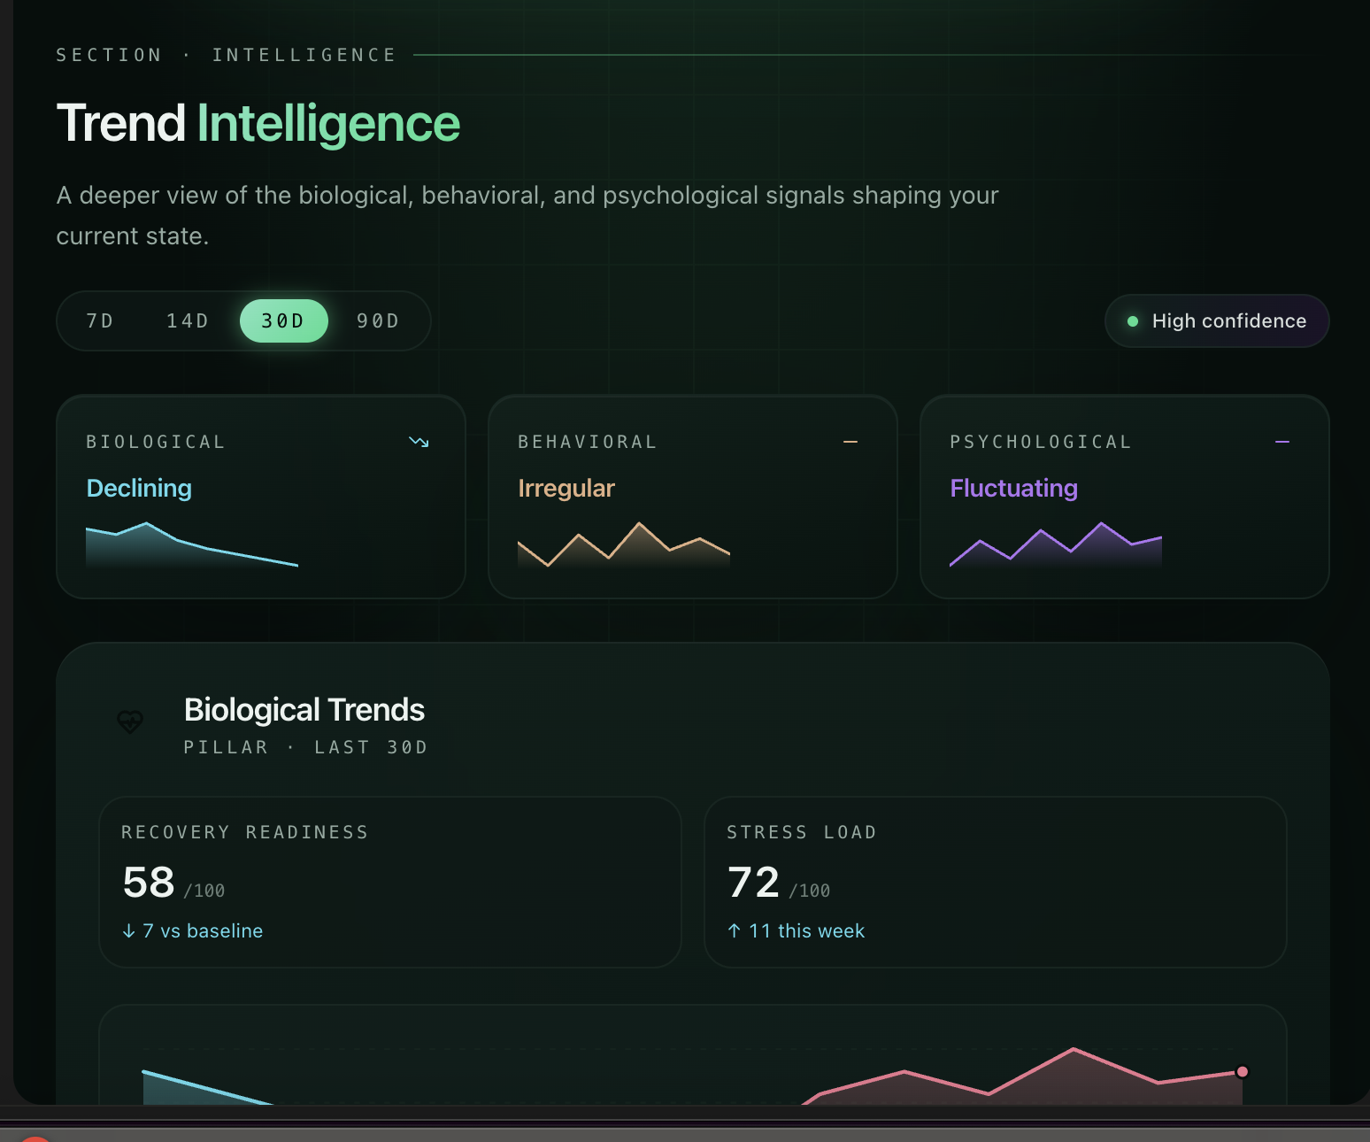
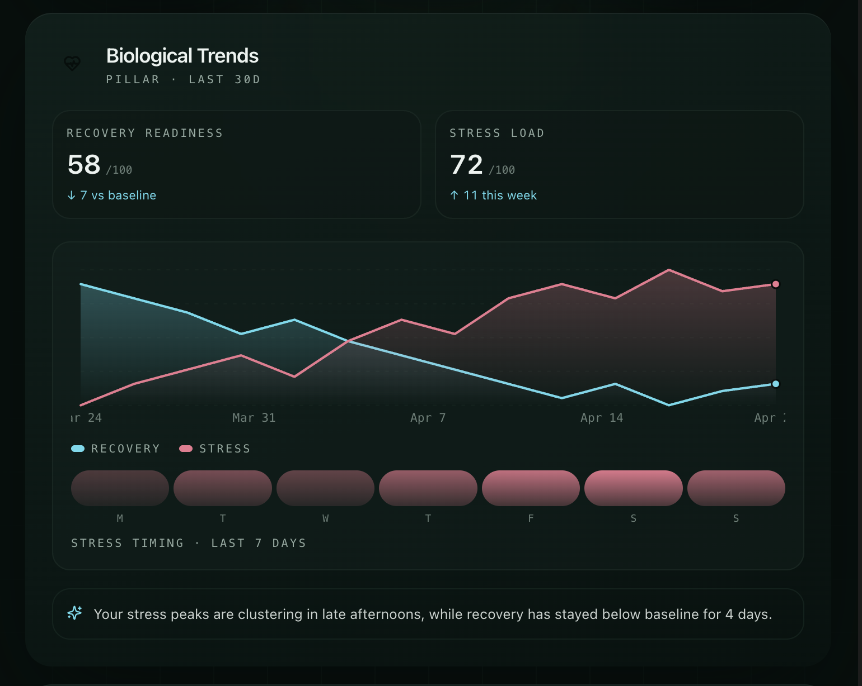
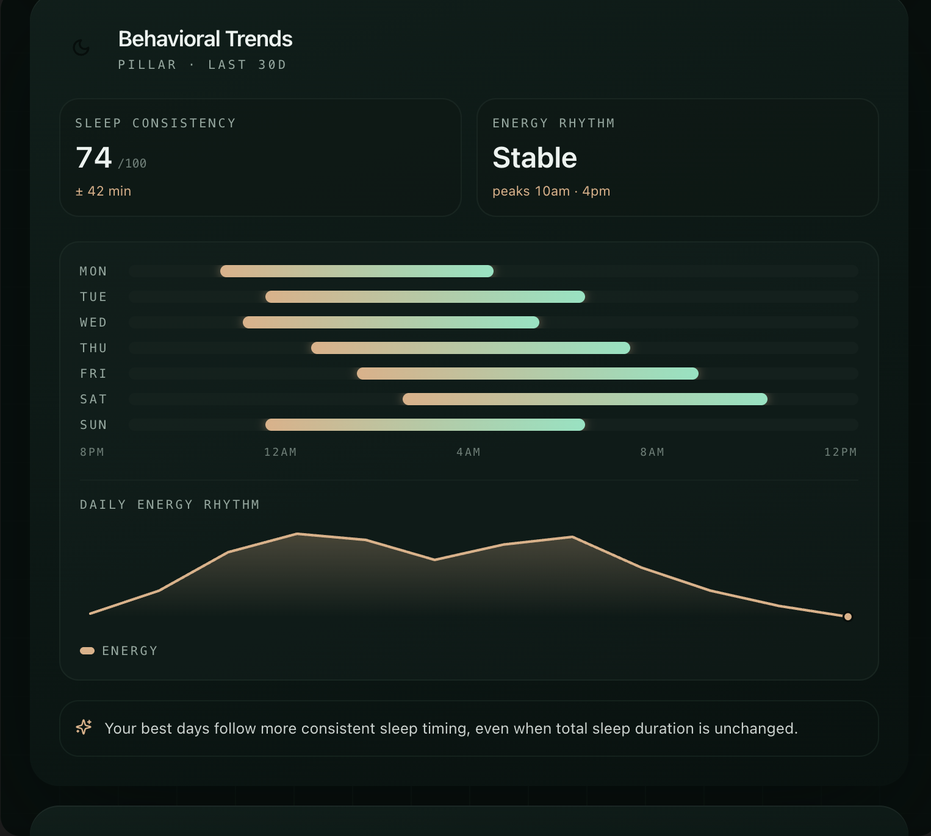
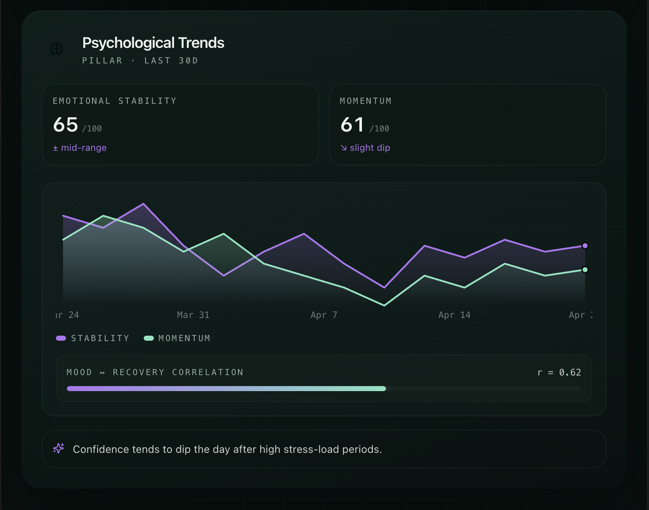
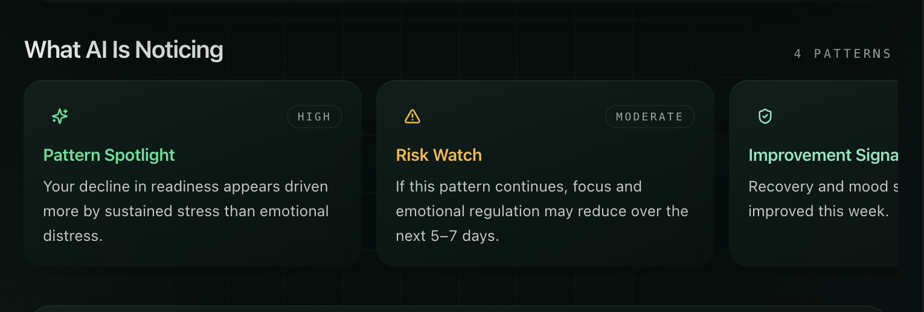
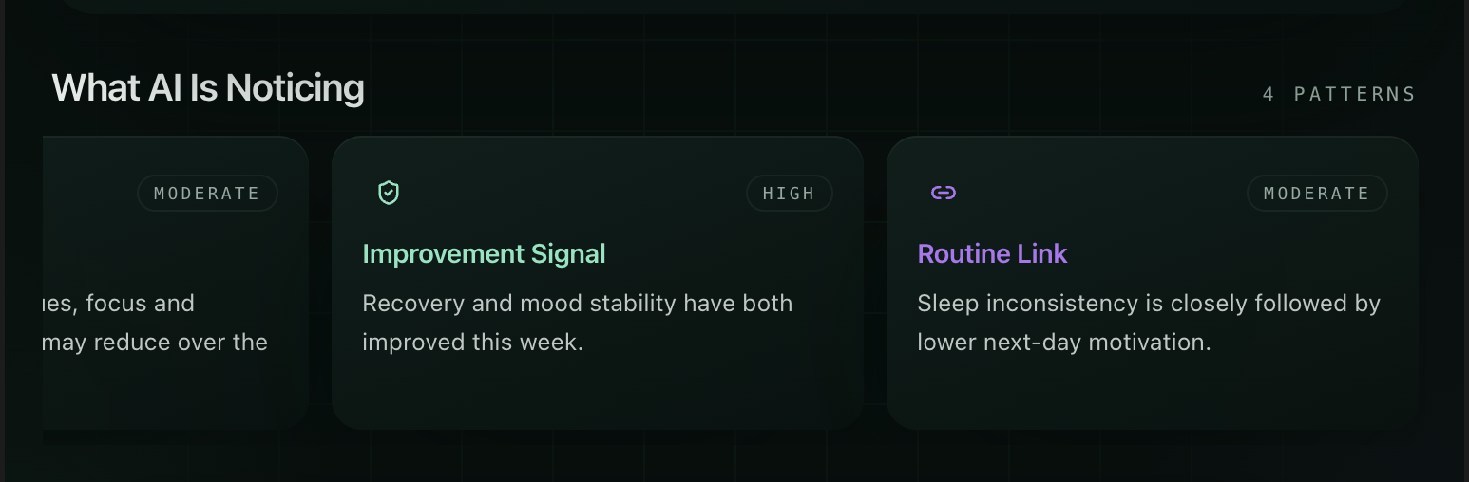

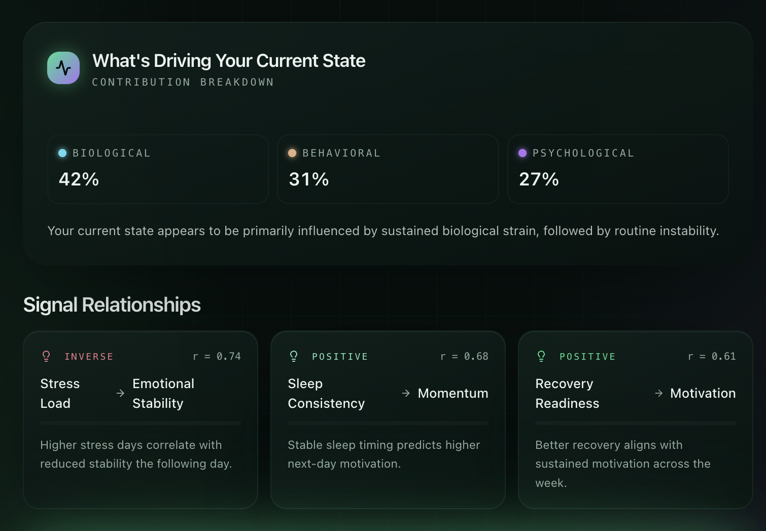
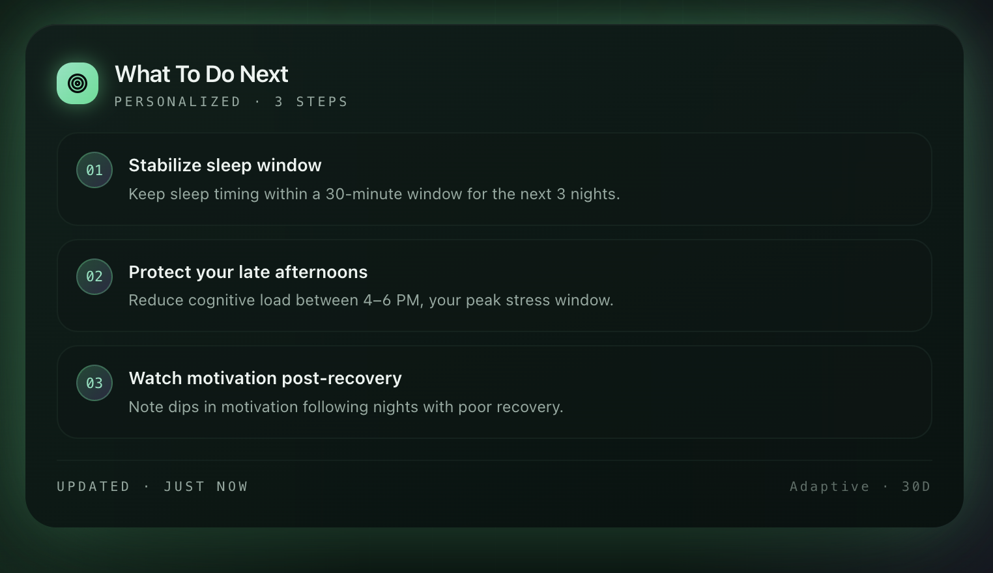
Ideation: https://docs.google.com/spreadsheets/d/1Mjizk0sXLM7VYUifIOmSTwq9wID2YhQiEfmRyQLlwR8/edit?usp=sharing

Section 1:

Build an AI-powered mental health report that combines biological, behavioural, and assessment (CORE-OM) signals into a single user-facing score called Cognitive Readiness Score, supported by 4 secondary dimensions:
- Clarity
- Emotional Balance
- Resilience
- Capacity
The report should answer:
- Where am I right now?
- Why am I here?
- What should I be aware of?
- What is the risk?
- What should I do next?

2. Inputs / Data Sources

2.1 Biological Inputs
Wearable-derived physiological and recovery markers.
Expected fields:
- HRV
- Resting heart rate
- Sleep duration
- Sleep efficiency
- Sleep consistency
- Night awakenings
- Deep sleep %
- REM sleep %
- Physiological stress score
- Recovery score
- Respiratory rate
- Skin temperature deviation
- Activity load / exertion load

2.2 Behavioural Inputs
Derived from daily routine and behaviour patterns.
Expected fields:
- Bedtime consistency
- Wake time consistency
- Steps / movement trend
- Sedentary time
- Late-night activity
- Routine deviation from baseline
- Activity consistency
- Support-seeking / app engagement frequency
- Check-in completion rate
- Behavioural rhythm irregularity

2.3 Assessment Inputs
Derived from CORE-OM or equivalent assessment.
Expected fields:
- CORE-OM total score
- Wellbeing sub-score
- Problems / symptoms sub-score
- Functioning sub-score
- Risk sub-score
- Assessment date
- Previous assessment score(s)
- Delta from previous assessment

3. Output Scores

3.1 Primary Score

Cognitive Readiness Score (0–100): Composite score representing current mental performance and wellbeing readiness.

3.2 Secondary Scores

Clarity (0–100): Represents mental sharpness, focus, and cognitive organisation.

Emotional Balance (0–100): Represents emotional steadiness, regulation, and distress load.

Resilience (0–100): Represents recovery capacity, adaptability, and bounce-back potential.

Capacity (0–100): Represents available functional bandwidth and ability to sustain daily demands.



Metric | Pillar | What it tells user | Why it matters
Recovery Readiness | Biological | How restored and physiologically ready the person is | Strong predictor of mental stamina and cognitive stability
Stress Load | Biological | Ongoing physiological strain across the day/week | Helps detect overload before burnout symptoms rise

Biological Trends

Metrics to show

1. Recovery Readiness
Derived from:
- HRV trend
- Resting heart rate deviation
- Sleep recovery markers
- Physiological strain baseline deviation
- Readiness vs baseline
Card copy:
Recovery Readiness: Moderate
Your body is recovering, but not fully restoring to its recent baseline.

2. Stress Load
Derived from:
- Physiological stress episodes
- Duration above stress baseline
- Frequency of high arousal periods
- Daytime strain accumulation
- Stress recovery lag
Card copy:
Stress Load: Elevated
Your system has been under sustained load for the past 5 days, with slower return to baseline than usual.

Best graphs for Biological Trends
- Dual-line trend graph
  - X-axis: time
  - Y-axis: score
  - Lines:
    - Recovery Readiness
    - Stress Load
- Baseline deviation graph
  - Show today vs personal baseline
  - Good as vertical bars
  - Example:
    - HRV: -12% below baseline
    - Resting HR: +8% above baseline
    - Stress exposure: +18% above baseline
- Stress episodes heatmap
  - Time of day x days of week
  - Highlights when physiological strain is highest

AI patterns to place here
Use 2–3 smart pattern chips/cards:
- AI noticed: Your stress peaks are clustering in late afternoons.
- AI noticed: Recovery has dropped for 4 days in a row despite stable sleep duration.
- Pattern emerging: Your body is returning to baseline slower than usual after high-stress periods.

B. Behavioral Trends



Metric | Pillar | What it tells user | Why it matters
Sleep Consistency | Biological + Behavioral | Whether sleep timing and quality are stable | Strongest driver of emotional regulation and readiness
Energy Rhythm | Behavioral | How stable the user’s daily activity and fatigue pattern is | Shows crashes, irregularity, disengagement

Metrics to show

Sleep Consistency
Derived from:
- Sleep duration stability
- Sleep-wake timing variance
- Sleep debt accumulation
- Night awakenings
- Recovery quality contribution
Card copy:
Sleep Consistency: Low
Your sleep timing has been irregular this week, which may be impacting focus and emotional regulation.

Energy Rhythm
Derived from:
- Activity regularity
- Inactivity/fatigue patterns
- Circadian consistency
- Engagement rhythm across day
- Drop-off timing patterns
Card copy:
Energy Rhythm: Uneven
Your daily energy appears strong in the morning but drops sharply by evening.

Best graphs for Behavioral Trends
- Sleep pattern band graph
  - Bedtime and wake-up consistency across days
  - Very good wearable-style visualization
- Daily rhythm graph
  - 24-hour activity/engagement curve
  - Shows peaks and crashes
- Weekly habit stability chart
  - Small bars for:
    - sleep regularity
    - activity consistency
    - downtime quality
    - routine adherence

AI patterns to place here
- AI noticed: Your best days follow nights with more consistent sleep timing, not necessarily longer sleep.
- Pattern emerging: Evening energy drop has become stronger over the last 2 weeks.
- AI noticed: Irregular routines are closely followed by lower motivation scores the next day.



Metric | Pillar | What it tells user | Why it matters
Emotional Stability | Psychological | How steady or volatile mood/emotional state is over time | Useful for spotting psychological drift
Motivation & Confidence Momentum | Psychological + Behavioral | Whether the person is moving toward engagement or withdrawal | Makes the dashboard action-oriented and relatable

Psychological Trends

Metrics to show

5. Emotional Stability
Derived from:
- Mood trend
- Mood variability
- Self-reported distress markers
- Core-OM shifts
- Emotional volatility pattern
Card copy:
Emotional Stability: Fluctuating
Your emotional state has shown more variability than usual, especially after high-stress days.

6. Motivation & Confidence Momentum
Derived from:
- Motivation check-ins
- Confidence levels
- Self-efficacy indicators
- Consistency of engagement
- Withdrawal vs activation trend
Card copy:
Motivation & Confidence Momentum: Declining
Your drive and confidence appear to have softened over the past 10 days, which may affect performance and follow-through.

Best graphs for Psychological Trends
- Mood variability line graph
  - Not just average mood
  - Show volatility band
- Momentum graph
  - Combined score line for motivation + confidence
  - Arrow indicator: improving / stable / dipping
- Correlation view
  - Tiny graph linking emotional dips with stress spikes or poor recovery
  - This is where AI feels powerful



Top pattern cards AI should generate from time to time

This is the important part. These are the AI components placed from time to time.

You should have a rotating module called:

Emerging Patterns/What AI Is Noticing

Show 2–4 cards max at a time.

Pattern card types

1. Correlation pattern

Example:

On days when your recovery dips, your confidence tends to fall the next day.

2. Repeating time-based pattern

Example:

Your stress load is consistently highest between 3 PM and 6 PM.

3. Warning pattern

Example:

Your current pattern resembles earlier periods of low motivation and overload.

4. Positive reinforcement pattern

Example:

Your emotional steadiness improves when sleep timing is consistent for 3+ days.

5. Drift pattern

Example:

Your baseline stress has gradually increased over the last 2 weeks.

6. Recovery pattern

Example:

You recover best on lower-activity days that still include routine movement and regular sleep.

AI component blocks you should place in this section

These are the best smart blocks to add:

A. Pattern Spotlight

A highlighted insight card:
Pattern Spotlight
Your current decline in readiness appears to be driven more by sustained stress than by emotional distress.

B. Risk Watch

A softer warning block:
Risk Watch
If this pattern continues, your ability to focus and emotionally regulate may reduce over the next 5–7 days.

C. Improvement Signal

Positive block:
Improvement Signal
Recovery and mood stability have both improved this week, suggesting your recent routine changes are helping.

D. Driver Breakdown

A small bar chart:

Biological influence: 42%

Behavioral influence: 31%

Psychological influence: 27%

E. Confidence in Insight

Since wearable/AI systems need trust:

High confidence

Moderate confidence

Limited confidence due to sparse data
Correlation and drivers: Dynamically from AI

What to do next? / Recommendation
AI-led next best action based on the user’s mood, risk signals, progress, and support history.
Tools / Resources
Relevant exercises, worksheets, videos, and guided activities recommended for the user’s current needs.
Self-Help
A complete library of self-guided resources the user can explore anytime.
Next Session
Prompt to book or continue therapy when the user may need deeper support.

